Fact Sheet for Student Exchange Program 2020

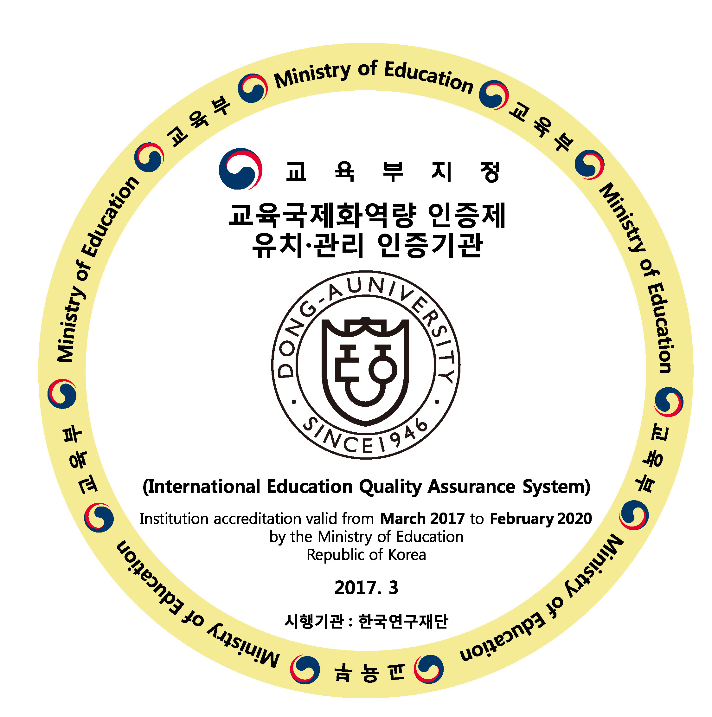

I. General Information
Name of University | Dong-A University
President | Suk-Jung Han
Institution dealing with exchange program | Office of International Affairs
Contact information | (tel) +82-51-200-6443  (fax)+82-51-200-6445
Location | Busan City  (The second Largest City in Korea)
Exchange program coordinator | <Outgoing Students> <Incoming Students >  Mr. Lee wonho (李元镐)  Email : lwh801010@dau.ac.kr
Website for exchange-related information | http://global.donga.ac.kr/sites/global/index.do

II. Application
Application procedure | All application documents must be submitted before the  deadline. Documents can be sent by email with PDF  files as we do not need original copies.
Required documents for application | 1. Application form(with a photo attached) (pdf)  2. Certification of Enrollment (pdf)  3. Certification of Transcript (pdf)  4. A photocopy of passport (pdf)  5. Korean language application(pdf)  6. 1 Photo(jpg)  7. Certificate of Insurance(pdf)  *for those who get insurance in his/her own country  8. Certificate of health including Tuberculosis  (pdf)  *Inspections for Tuberculosis must be done in hospitals appointed by hospitals in provinces appointed by the Korean embassy(If a visa application includes a tuberculosis test, you do not need to submit it)
Deadline for application | Fall/1st Semester | Spring/2nd Semester
Deadline for application | May 20th | Nov 20th
Suggested length of study for exchange | Both are OK(one semester or one year)
Number of exchange students allowed  (Semester and Yearly) | According to agreement
Suggested level of language proficiency for exchange program | None
Estimated time to deliver acceptance letter | Fall/1st Semester |  | Spring/2nd Semester
Estimated time to deliver acceptance letter | June 30th |  | Dec 30th
Procedure of applying for student visa | Acceptance letter can be used as a supporting  document for your visa and you can take it to the  nearest Korean Embassy.

III. Course Information
Course list  (if online list is unavailable, please mail coordinator) | http://english.donga.ac.kr/english/9679/subview.do
Do you offer English-Taught Courses? List available? | http://english.donga.ac.kr/english/9679/subview.do
Any limitation or suggestion on course selection? | A certain level of Korean Language Proficiency is required for the better course.
Preliminary language training classes provided? | http://dms.donga.ac.kr/global/7358/subview.do  (For exchange students, Korean language is optional)
Necessary pay to preliminary language training class? | Free for Exchange Students(Some universities have to pay tuition)  (4hours/a day, from Monday to Friday)

IV. Scholarship
Any scholarship provided to exchange program? | Scholarship will be offered according to the agreement signed with partner university

V. Accommodation
Type of accommodation offered? | Two students in one room
Fees of on-campus dormitory | - Seunghak Campus [(amount for a semester(4 months)]  ·Male students(New dorm) : 833,700 KW  ·Female students(Old dorm) : 733,400 KW
Off-campus housing assistance is provided? | Yes, but limited. We strongly recommend to live on-campus if you are new incoming student
Maximum beds offered to every partner school? | Yes
Any limitation or suggestion on accommodation? | Dormitory is allocated by Office of International Affairs

VI. Expense (in local currency)
Insurance | Students will have to get an insurance in his/her own country or get an insurance once he/she arrives South Korea  (1semester : 70,000KW, about $60, 1year : 130,000KW, about $110)
Meal | 3,500~4,000KW/lunch in university
Public Transport | 60,000KW/month(estimated)

